# Guide: Kinvey

Introduction to Kinvey for the ["VueJS Fundamentals @ Softuni"](https://softuni.bg/trainings/2430/vuejs-fundamentals-july-2019)

## Kinvey

Kinvey is a **BaaS** provider that makes it easy for developers to set up, use, and operate a **cloud back-end** for their apps. It holds **users** (API for creating an account), **user data** and **data collections** (API for CRUD operations).

## Register

The first thing to do is create an account in [Kinvey](https://console.kinvey.com/sign-up), followed by creating an app.

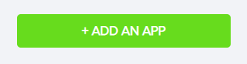

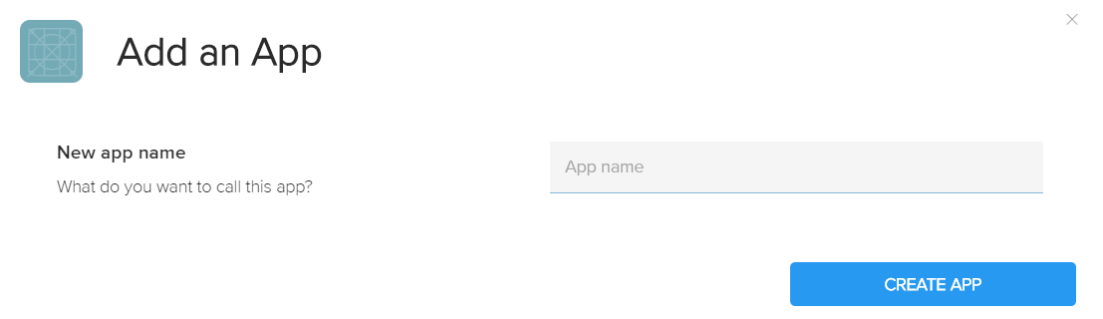

In order to get the **App ID** and **App Secret** of your app, you need to click on the **Development** button. For more information, see the picture below.

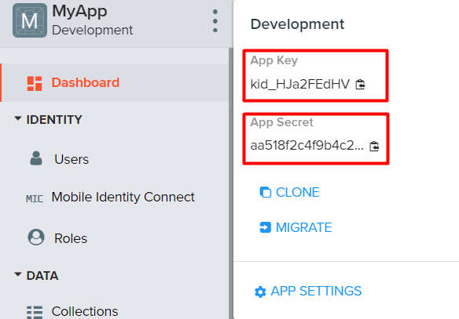

## Create a User

In order to **create a user**, click on “**Users**” right below “**Identity**” in the menu.

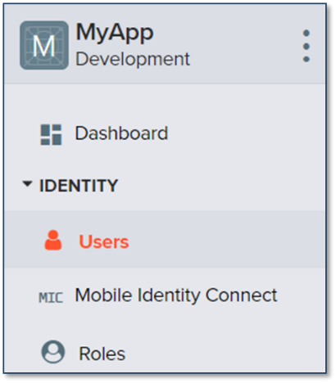

After that, you will see two buttons. Click on the “**Add User**” one.

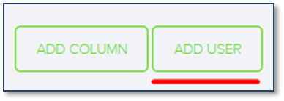

Then the following form will show up:

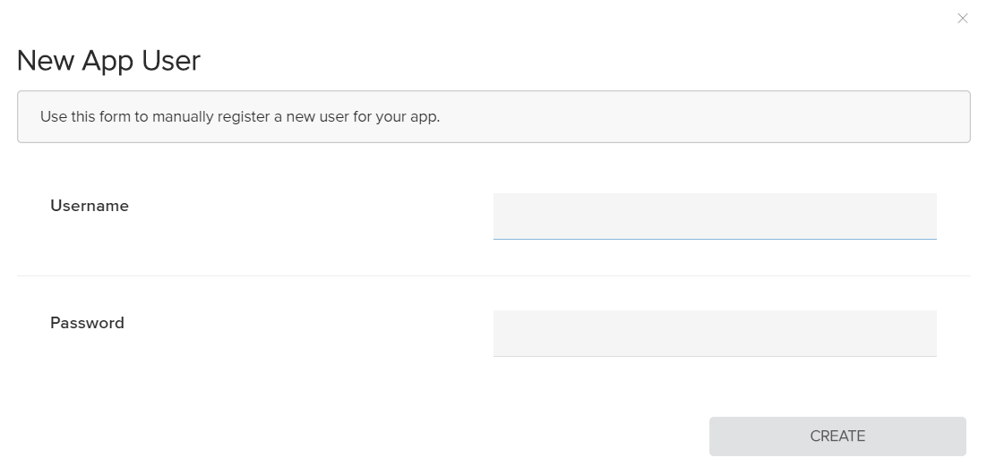

Write “**guest**” in both of the **username** and **password** fields. Then click on the “**Create**” button.

## 2.3 Create a Data Collection

In order to **create a collection**, click on “**Collections**” right below “**Data**” in the menu.

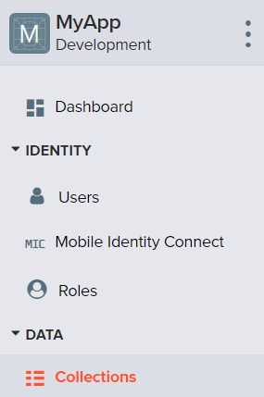 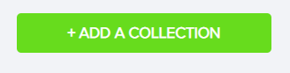

Then the following form will show up. Write the **name of your collection** in the field (for example, you can name it *posts*).

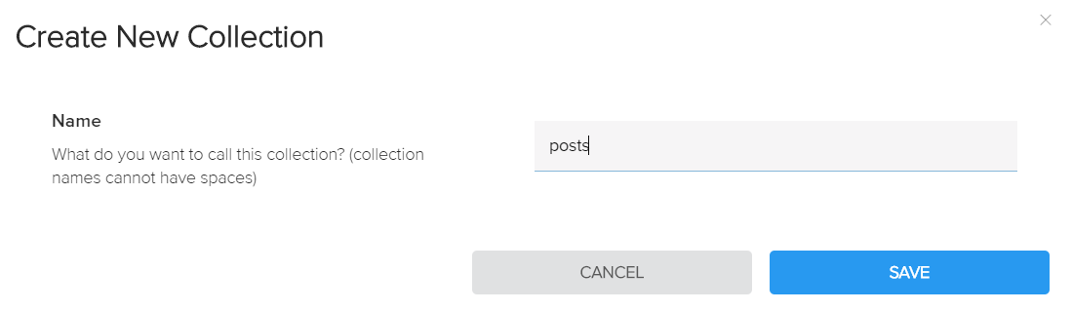

## Create Data Columns

Now it is time to **create** some **data columns** for our collection. Click on the “**Add Column**” button. Provided we have named it “posts”, it would be appropriate for a single post to have a **title** and a **body**.

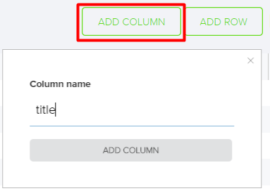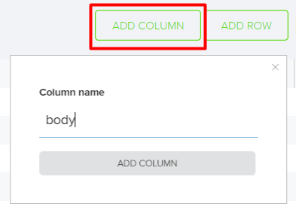

## Create Data Rows

Click on the “**Add Row**” button in order to **create** some **rows** for your collection and **insert data** in them.

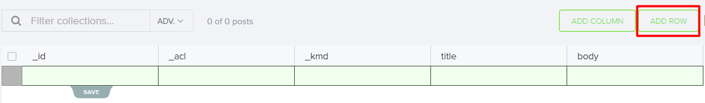

Manually fill in the “**title**” and “**body**” fields with the information provided below and **save** it.



After having clicked on “save”, you will see the following:

